The Dynamic Duo of Americana Music

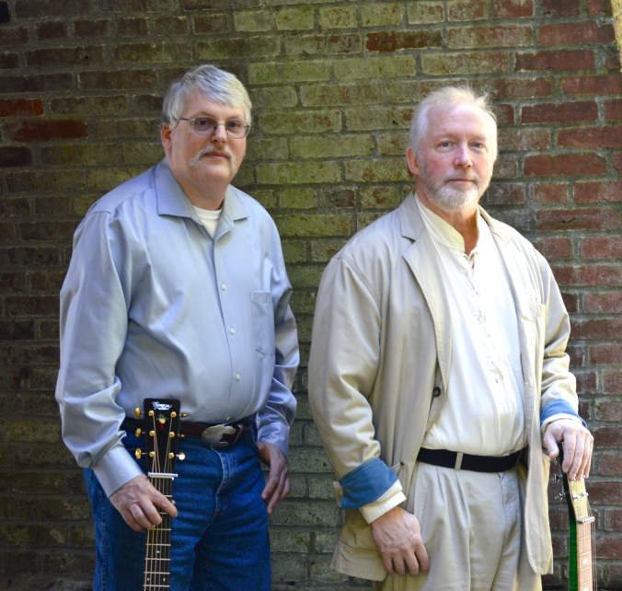
Slipshod is Matt Snook (dobro and banjo) and Steve Blanchard (guitar and mandolin). They met a number of years ago as part of the Northwest Bluegrass community and became fast friends and picking partners. They have similar musical styles, yet they draw on many different influences like Gordon Lightfoot, Norman Blake, Simon and Garfunkel, and Tim O’Brien, to name a few.

Slipshod formed in 2012. The musicians enjoy entertaining audiences with both their humor and musical skills. Matt and Steve offer listeners a broad and diverse range of music, including originals, familiar melodies and dynamic instrumentals. Their harmonies and unique vocal interpretations add to their precise instrumental talents.

Matt has entertained with a variety of ensembles including the Snook Family Band, Free Range and SugarPine. Steve has performed with Steve Blanchard and the Open Range, Bill Jolliff Bluegrass Gospel Band, Prairie Flyer, Jim Faddis and One More Ride and also, SugarPine.

If you’re looking for a fun, energetic band for your next event, party or festival, consider Slipshod. Check out this dynamic duo on their web site and Facebook and watch video performances on YouTube.

Contact:
Steve Blanchard Matt Snook
503-730-0005 541-805-5133
Steve@SteveBlanchardMusic.com BohemianBanjo@gmail.com
www.SlipshodMusic.net

What People Are Saying About Slipshod:

“Slipshod is the real deal. Professional musicians who respect the art of creating music and presenting it in a fun and intelligent performance. They understand that it’s the music business and treat it as such, making them easy to work with. It’s easy for me to recommend them for any venue.”

Ken Cartwright
Festival and Concert Promoter
Music Program Director for KMUZ and KYAC Community Radio

“Don’t let this band’s name fool you! Their mastery of the bluegrass/folk genre is ANYthing but slipshod. This Blanchard-Snook pairing is a wonderful balance of fluid instrumentals, strong vocals and good humor. Go see ’em!

Debby Kooy
Director, George Washington Coffee House, George Bluegrass Festival

Partial Play List:

Age
Annabelle
Black Mountain Rag
Brave Mountaineers
Church Street Blues
Columbus Stockade Blues
Did She Mention My Name
Early Morning Rain
Fast Train to Georgia
Ginseng Sullivan
Green Light on the Southern
High Cost of Living
Hobo Song
Important Part of Fishing
Last Thing On My Mind
Lay Down My Old Guitar
Leaves that are Green
Midnight Moonlight
Moonshiner
Nashville Blues
Nellie Kane
Old Gray Mare
One More Dollar
Prairie Wind
Randall Collings
Roadside Stand
Song of Wyoming
Southern Filibuster
Southern Flavor
Sunny Tennessee
Sweetest Song
Trouble and Pain
Walking Cane
Way Downtown
Whiskey Before Breakfast
Wichita
You’re Gonna Make Me Lonesome

Poster on Next Page:

The Dynamic Duo of Americana Music

